S_ALR_87011994 -

Functionality
Report RABEST01 is for displaying values of fixed assets.

Output
The report displays the values of all assets in a depreciation area. The following values are displayed in detail per asset:
- The cumulative acquisition value at the beginning of the fiscal year
- Accumulated depreciation, including the planned depreciation for the current fiscal year (the sum of all depreciation types)
- The planned book value at the end of the reporting year
Additional standard versions of the report allow for primary selection and creation of totals according to various criteria (asset class, business area, cost center, and so on).

Scenario
This transaction is used to display various asset values and can be used at month end for control purposes.

Requirements
None.

Menu Path | Accounting → Financial Accounting → Fixed Assets → Information System → Reports on Asset Accounting → Asset Balances → Balance Lists → Asset Balances → S_ALR_87011964 - ... by Asset Class
Transaction Code | S_ALR_87011994

1. Double Click on S_ALR_87011964 - ... by Asset Class
Asset Balances

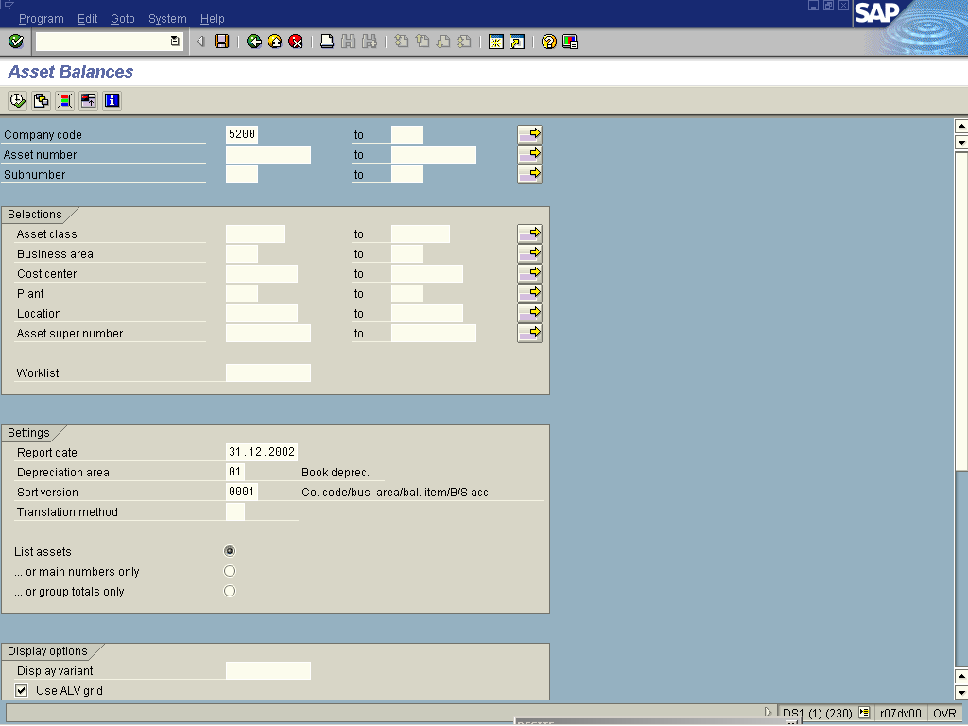
2. Click More fields Button .
3. Click <radio button> List assets .
4. Update the following fields:

Field Name | Field Description | Values
Company Code | Organizational unit within financial accounting. | Example: 5200
Report Date | Enter the last day of the financial period | Example: 31.12.2002
5. Click the Enter button to validate the entries.
6. Click Execute .

Asset Balances

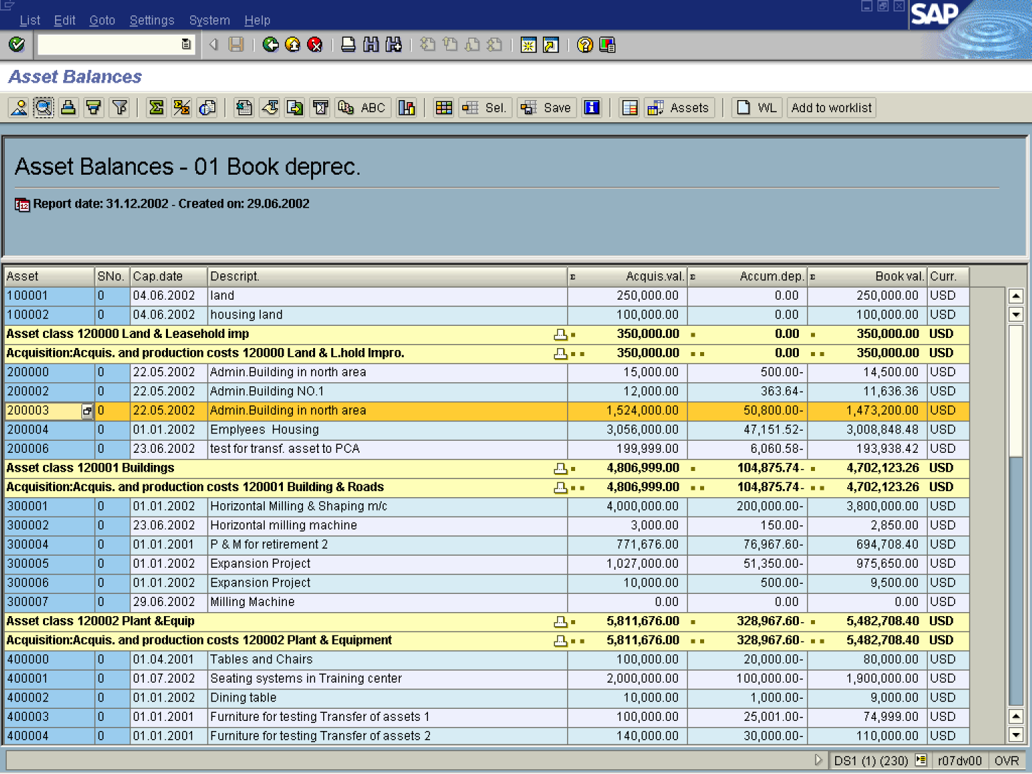

7. Select asset line 200003 0 22.05.2002 Admin Building in North Sea.
8. To view its details, click on the Details .

Details

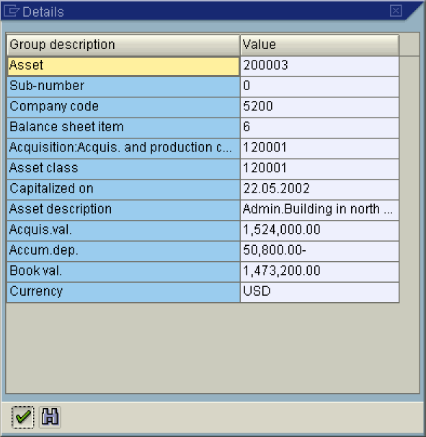

9. To Exit, click the Enter Button .

Asset Balances

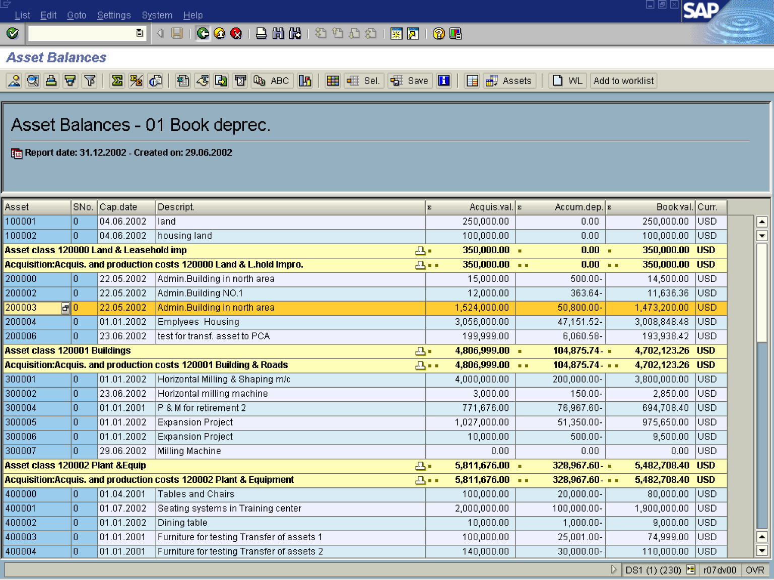

10. To Exit the report, click Back.

